**Recipe Organizer (Angular Project)**

**Home Page - Recipe Organizer**

The Home Page serves as the main entry point, featuring an attractive UI, smooth navigation, and interactive elements for a great user experience.

**HomeComponent (home.component.ts & home.component.html)**

* Displays the landing page with a navigation bar and an "Explore Recipes" button.

**Routing & Navigation**

* Implemented RouterModule for seamless navigation.
* The Explore Recipes button uses routerLink="/recipes" to navigate to the Recipes page.

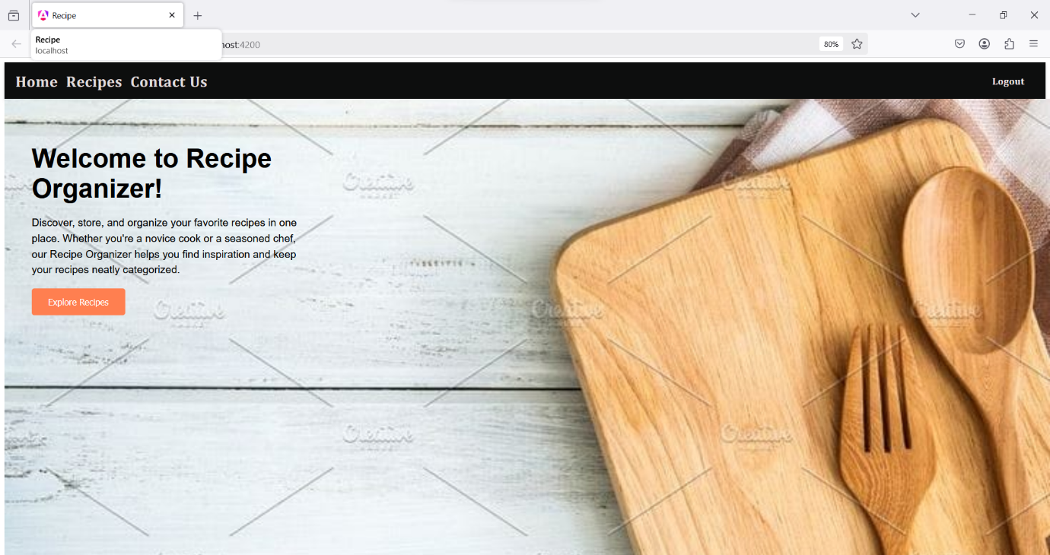

**Recipe Page - Recipe Organizer**

The **Recipe Page** in the Recipe Organizer displays a dynamic list of recipes using **RecipesComponent** (parent) and **RecipeCardComponent** (child) with @Input and @Output for data sharing. It utilizes **structural directives** (*ngFor, *ngIf) for rendering, **attribute directives** ([ngClass], [ngStyle]) for styling, and **routing parameters** to navigate to recipe details (/recipe-detail/:id). **RecipeService** fetches data via **API calls** using HttpClient.

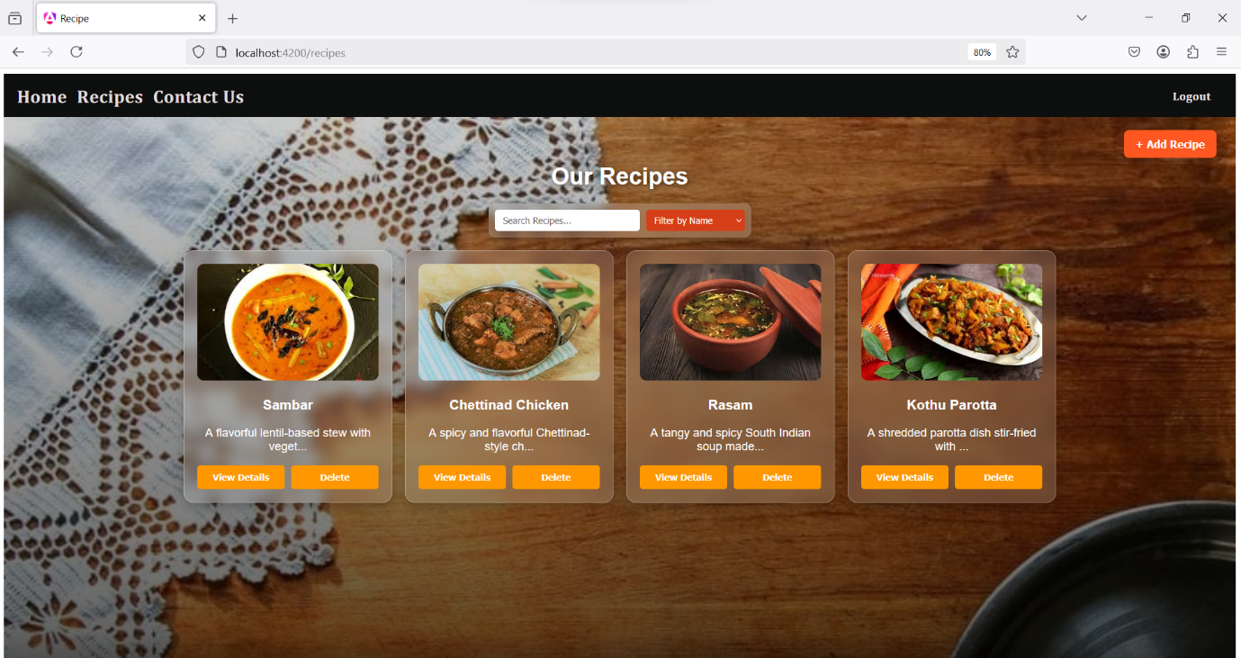

**Recipe Filtering Concept in Recipe Page**

Filtering in the Recipe Page is achieved using **Forms, Custom Pipes, Directives, and API Calls** for dynamic and efficient searching.

* **Form Handling:** A search input field allows users to enter keywords to filter recipes. This is implemented using a template-driven approach with ngModel or a reactive form for better control.
* **Custom Pipe:** A filtering pipe processes the input and returns only recipes matching the search term, ensuring real-time updates in the UI.
* **Structural Directives:** The *ngFor directive dynamically displays filtered recipes, while *ngIf ensures only relevant content is shown.
* **Attribute Directives:** ngClass highlights search results, and ngStyle modifies styles based on user input to enhance visibility.
* **API Integration:** If filtering is done on the backend, an API call is triggered to fetch relevant recipes dynamically, ensuring scalability.

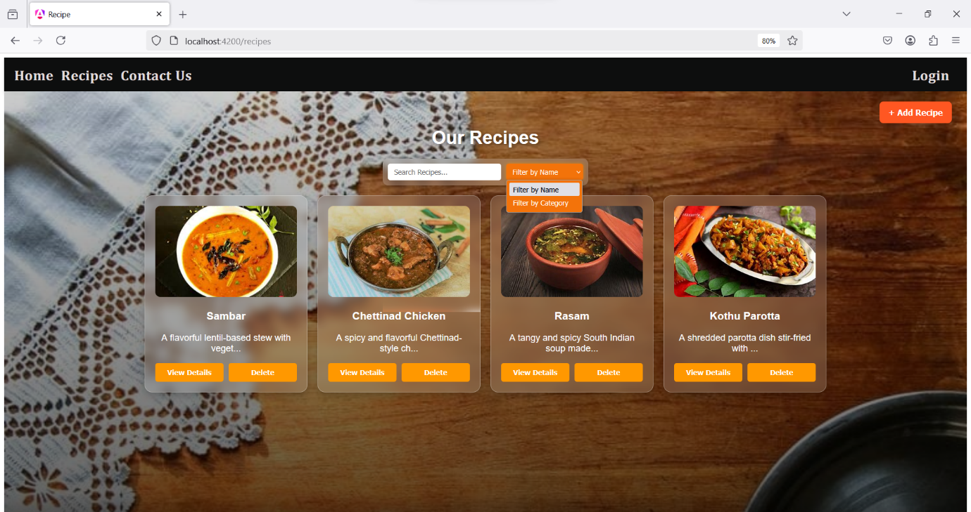

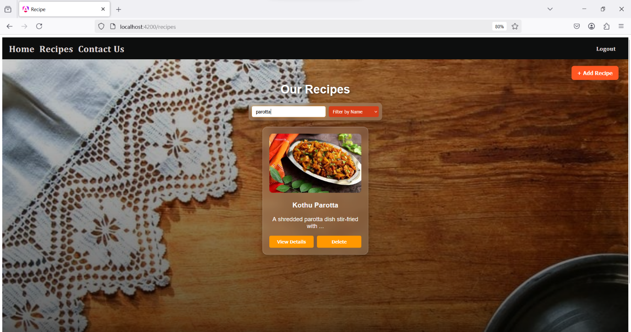

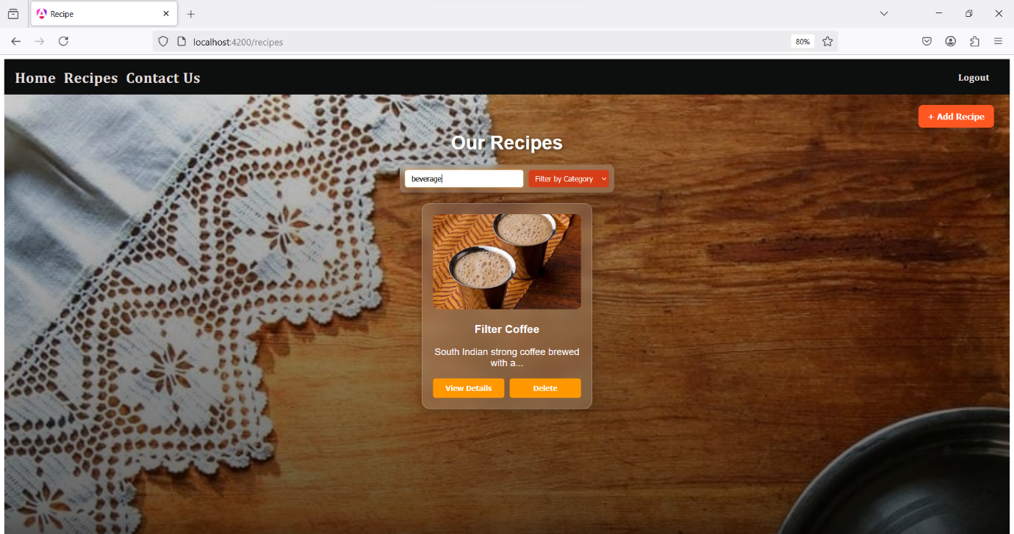

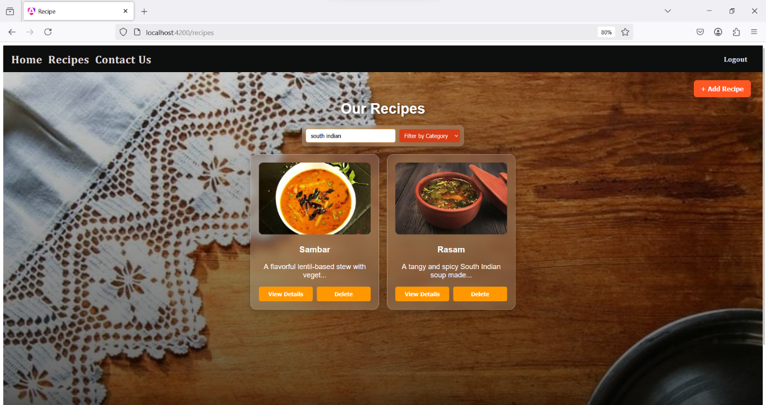

**Login Page Overview**

The **Login Page** provides secure access to the Recipe Organizer. It uses **Form Handling, Routing, Authentication Service, and Route Guards** to restrict access to certain features.

* **Form Handling:** Users enter their credentials in a login form with validation.
* **Services & Observables:** The authentication service verifies user credentials and stores session data.
* **Routing & Route Guards:** After login, users are redirected to the homepage. **AuthGuard** ensures that only logged-in users can view, add, or delete recipes.

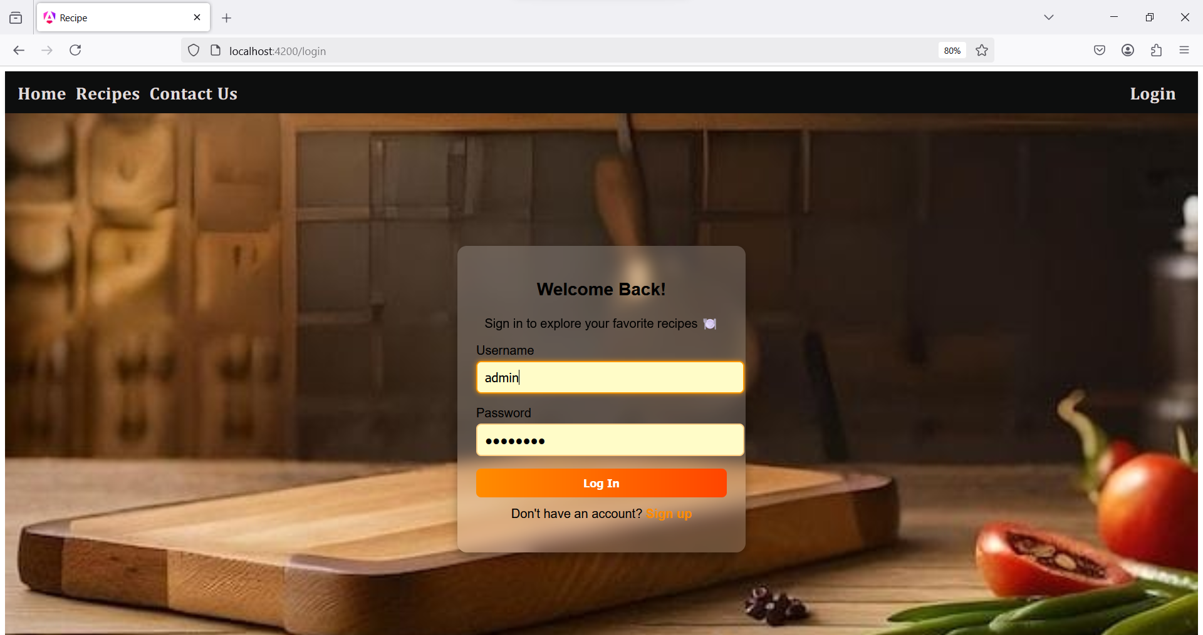

**Recipe Detail Page Overview**

The **Recipe Detail Page** displays complete information about a selected recipe, including its image, description, ingredients, and instructions.

* **Routing & Parameters:** Uses **ActivatedRoute** to retrieve the recipe ID from the URL and fetch the corresponding details.
* **@Input Decorator:** If part of a child component, @Input() is used to receive recipe data from the parent.
* **Route Guard:** Ensures only authenticated users can view this page. If not logged in, they are redirected to the **Login Page**.

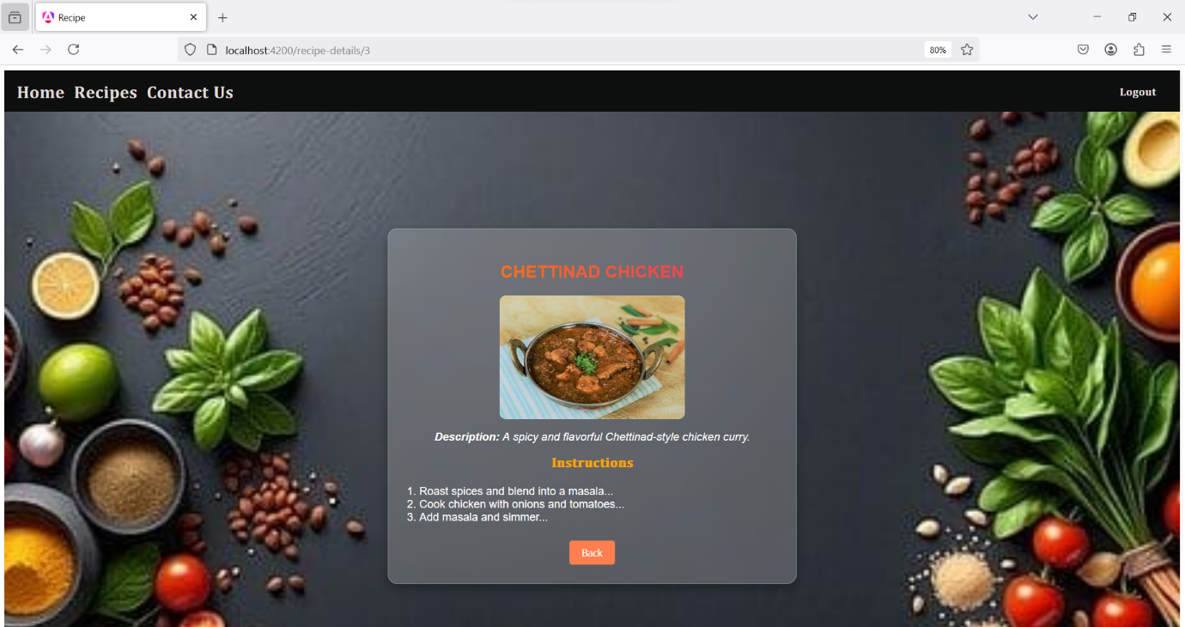

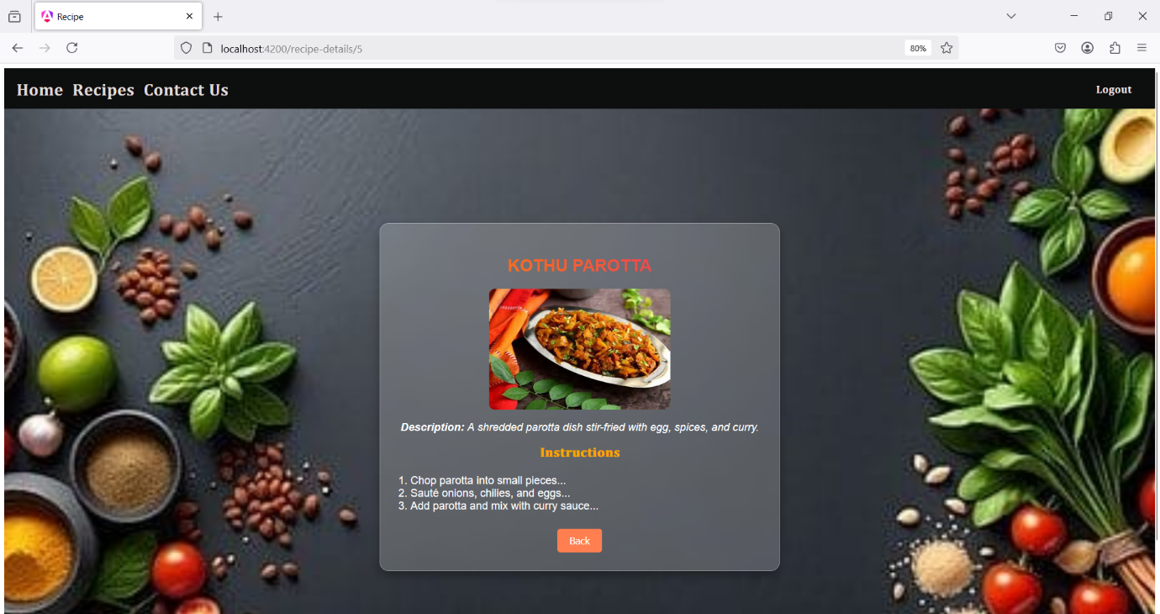

**Add Recipe Page Overview**

The **Add Recipe Page** allows users to submit new recipes using a structured form. It utilizes **Form Handling (Template/Model-Based), Services, Routing, and Validation** to ensure a seamless experience.

* **Form Handling:** Users enter recipe details (title, ingredients, instructions) using a **reactive form** with validation for required fields.
* **Services & Observables:** The form data is processed and sent to a service, which updates the recipe list dynamically.
* **Routing:** After a successful submission, the user is redirected to the recipe list using the Angular Router.
* **Directives:** *ngIf and *ngFor manage form visibility and validation messages.

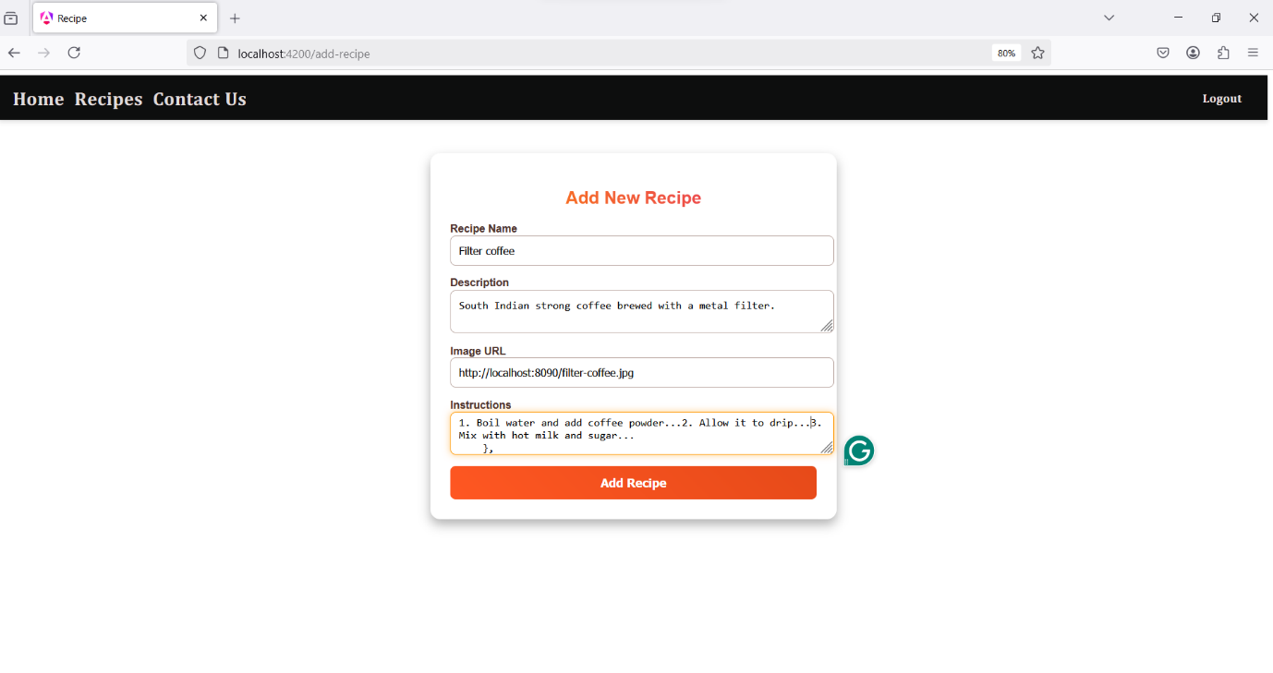

**After adding Filter Coffee**

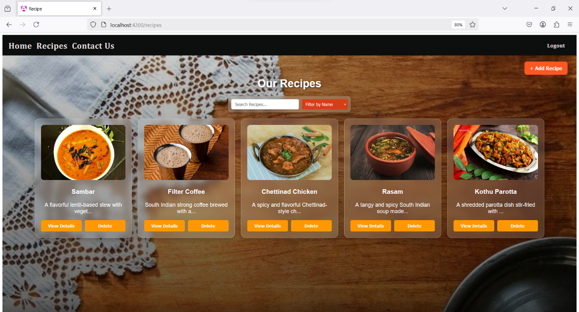

**Delete Recipe Feature**

The **Delete Recipe** feature allows authenticated users to remove recipes from the list.

* **@Input & @Output:** The recipe list receives data via @Input, and deletion is triggered using @Output to notify the parent component.
* **Services & Observables:** A **RecipeService** manages recipe data, and an observable updates the UI after deletion.
* **Routing & Guards:** Only logged-in users can delete recipes, enforced by **AuthGuard**.

**After deleting Filter coffee**

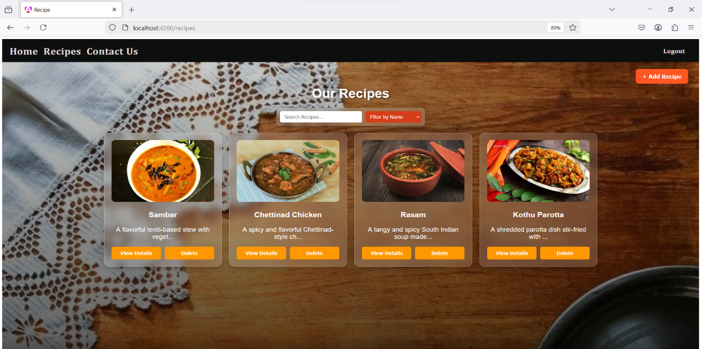

**Contact Page**

The **Contact Page** provides users with a way to reach out for inquiries or feedback.

* **Component:** ContactComponent displays a form with name, email, and message fields.
* **Form Handling:** Uses **Template-Driven Forms** for input validation.
* **Routing:** Accessible via /contact using Angular **RouterModule**.

